Name
Class
Class no.
Date
Marks | / 50
Carmel Holy Word Secondary School
2024-2025 Term 1
Secondary 3 Computer Literacy
Practical Assessment
Time: 45 Minutes

- Write your Name, Class and Class Number in the boxes provided.
- Follow the instructions below to finish the examination tasks.
- If you fail to upload your work, NO MARK will be given.
- Only open the link in Teams and the specified project in MIT App Inventor 2. DO NOT browse other websites or previous project assignments.

- ALL TASKS should be finished in MIT App Inventor 2.
- Login to Teams and open a folder named “S3 Term 1 Practical Assessment”.
- Download the files “task1_2425.aia”, “task2_2425.aia” and “task3_2425.aia” to your computer.
- Submit your work to the appropriate assignments in Teams.

Task 1 (15 marks)
Figure 1 shows the interface of Task 1.
(a) Download “task1_2425.aia” from Teams and import it into MIT App Inventor 2.
- Insert an ImageSprite on the Canvas with the following properties:
  - Name: “balloon”
  - Width: 50px
  - Height: 70px
  - X: 135
  - Y: 150
  - Picture: “balloon.png”

- Add the following blocks:
When ImageSprite "balloon" is being touched,
Move ImageSprite "balloon" upward by 10 pixels.
- Add the following blocks:
When ImageSprite "balloon" reached the edge,
Change the picture of ImageSprite to "balloon_break.png".
- Export “task1_2425.aia” and submit it to Teams.

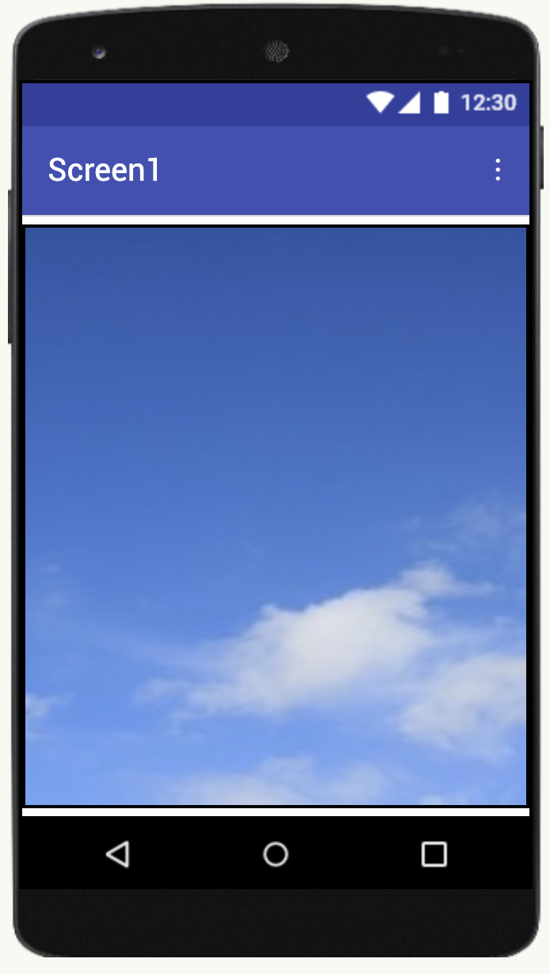

Figure 1

Task 2 (15 marks)
Figure 2 shows the interface of Task 2.
(a) Download “task2_2425.aia” from Teams and import it into MIT App Inventor 2.
(b) Add the following blocks:
When Screen1 is being initialized
Change the heading of Ball " movingBall" to a random integer between 0 to 360.
Change the speed of Ball "movingBall" to a random integer between 5 to 15.
(c) Add the following blocks:
When the Ball "movingBall" reaches the edge
Ball "movingBall" bounces off the edge.
(d) Add the following blocks:
When the ImageSprite "player" is being dragged
Move ImageSprite "player" to the current touched position.
(e) Export “task2_2425.aia” and submit it to Teams.

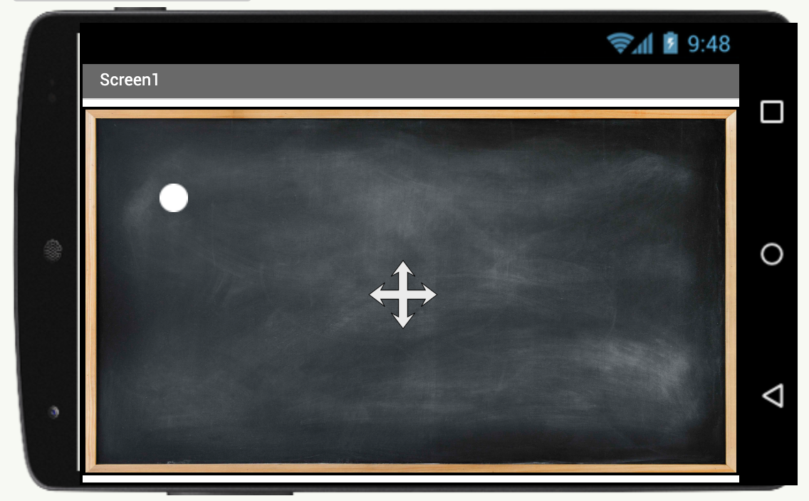
movingBall
player
board

Figure 2

Task 3 (20 marks)
Figure 3 shows the interface of Task 3.
(a) Download “task3_2425.aia” from Teams and import it into MIT App Inventor 2.
(b) Add the following blocks:
When Clock "clock" is timer triggered
Call TeachableMachineImageClassifier "tmic" to classify video data.
(c) Add the following blocks:
When ImageSprite "basket" collides with ImageSprite "fruit",
Change the position of ImageSprite "fruit" to the top of the screen.
Increase the text of the Label "score" by 1.
(d) Add the following blocks:
When the ImageSprite "fruit" reaches the edge
Change the position of ImageSprite "fruit" to the top of the screen.
(e) Add the following blocks:
When the TeachableMachineImageClassifier "tmic" got classification
If the result value for "Left" is greater than "Right":
Change the heading of ImageSprite "basket" to move left.
Change the speed of ImageSprite "basket" to 10.
Else
Change the heading of ImageSprite "basket" to move right.
Change the speed of ImageSprite "basket" to 10.
(g) Export “task3_2425.aia” and submit it to Teams.
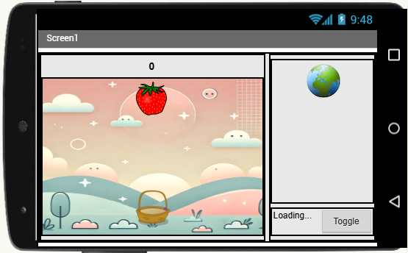
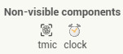

Figure 3
End of Paper

